|  |  |
| --- | --- |
| **Computer Science 1** | **Lab 08A**  **Multi-Day Major Python Assignment** |
| **Repetition with Turtle Graphics** | **50 *through* 110 Point Versions** |
| **Assignment Purpose:**  The purpose of this lab assignment is to gain understanding of repetition control structures, like the **for** loop, visually using *Turtle Graphics*. | |

This assignment is similar to Lab 5A in that it uses *Turtle Graphics* and requires you to create a series of shapes and designs. The difference is now the shapes and designs are more complicated and require the use of a **for** loop. As with Lab 5A, there are a total of 13 images. The first image is worth **50** points and the other 12 are worth **5** points apiece. Completing the first image and any 10 of other 12 will earn a grade of 100. Completing all 13 images will earn the maximum grade of **110**.

A *skeleton* for the program has been written for you. If you look at the provided code, you see the proper libraries have been imported and the dimensions of the Turtle Graphics window have been “set up”. Then there are 13 different sections, one for each shape/design. Each section begins with a comment showing its name and ends with 4 commands. These commands are commented out for now. In-between is where you write the code for that particular shape/design. Once you do, you need to uncomment the **update**, **sleep**, **reset** and **tracer** commands so that after the computer draws the shape/design, it will update the screen, wait one second, and reset the window and speed up the turtle for the next shape/design.

NOTE: If you need more space to write your code, you can just press the <enter> key and insert as many blank lines as you wish.

|  |  |
| --- | --- |
| **Lab 08A Student Version** | **Do not copy this file, which is provided.** |
| **1 # Lab08Ast.py  2 # "Repetition with Turtle Graphics"  3 # This is the student, starting version of Lab 08A.  4 # After completing each shape, student need to "un-comment"  5 # the 4 commands which follow before they start the next shape.  6   7   8 from turtle import *   9 from time import sleep  10   11 setup(1300,700)  12 tracer(0,0)   13   14   15 #########################################   16 # Diagonal Initials - 50 Points #  17 #=======================================#  18 # In order to receive credit, you #  19 # must have at least FOUR sets of #  20 # YOUR initials displayed diagonally. #   21 # The initials must be evenly spaced #  22 # and a <for> loop must be used. #  23 #########################################  24   25   26   27   28   29   30 #update()   31 #sleep(1)  32 #reset()  33 #tracer(0,0)  34   35   36 #######################  37 # Solid Red Octagon #  38 #######################  39   40   41   42   43   44   45 #update()   46 #sleep(1)  47 #reset()  48 #tracer(0,0)  49   50   51 ###################  52 # 15 Point Star #  53 ###################  54   55   56   57   58   59   60 #update()  61 #sleep(1)  62 #reset()  63 #tracer(0,0)  64   65   66 ###############  67 # Plus Sign #  68 ###############  69   70   71   72   73   74   75 #update()  76 #sleep(1)  77 #reset()  78 #tracer(0,0)  79   80   81 ############################################  82 # Big Thick Snowflake with 2 Thin Babies #  83 ############################################  84   85   86   87   88   89   90 #update()  91 #sleep(1)  92 #reset()  93 #tracer(0,0)  94   95   96 ############  97 # Circle #  98 ############  99  100  101  102  103  104  105 #update() 106 #sleep(1) 107 #reset() 108 #tracer(0,0) 109  110  111 ######################## 112 # Horizontal Zig-Zag # 113 ######################## 114  115  116  117  118  119  120 #update() 121 #sleep(1) 122 #reset() 123 #tracer(0,0) 124  125  126 ################## 127 # Cool Pattern # 128 ################## 129  130  131  132  133  134  135 #update()  136 #sleep(1) 137 #reset() 138 #tracer(0,0) 139  140  141 ########################## 142 # Flower of 12 Squares # 143 ########################## 144  145  146  147  148  149  150 #update() 151 #sleep(1) 152 #reset() 153 #tracer(0,0) 154  155  156 ########################## 157 # Flower of 10 Circles # 158 ########################## 159  160  161  162  163  164  165 #update() 166 #sleep(1) 167 #reset() 168 #tracer(0,0) 169  170  171 ##################### 172 # Westbound Comet # 173 ##################### 174  175  176  177  178  179  180 #update() 181 #sleep(1) 182 #reset() 183 #tracer(0,0) 184  185  186 ################ 187 # Box Spiral # 188 ################ 189  190  191  192  193  194  195 #update() 196 #sleep(1) 197 #reset() 198 #tracer(0,0) 199  200  201 #################################### 202 # Triple Nested Golden Honeycomb # 203 #################################### 204  205  206  207  208  209  210 update() 211 done()**  **212** | |

**The First 50 Points**

To earn your first 50 points, you need to draw your initials at least 4 times in thin, block-style letters in turtle graphics.

NOTE: THESE MUST BE YOUR INITIALS AND THEY MUST BE EVENLY SPACED!

For example, if your name is “John Smith”, you would draw the letters ‘J’ and ‘S’ in thin, block-style letters, 4 or more times, as shown below. You will NOT receive credit if you draw initials that are not yours. You will also not receive credit if the initials are not evenly spaced or if you fail to use a **for** loop.

NOTE: If you are confused as to how to do this, the process is explained and demonstrated in **LabVideo08A.mp4**.

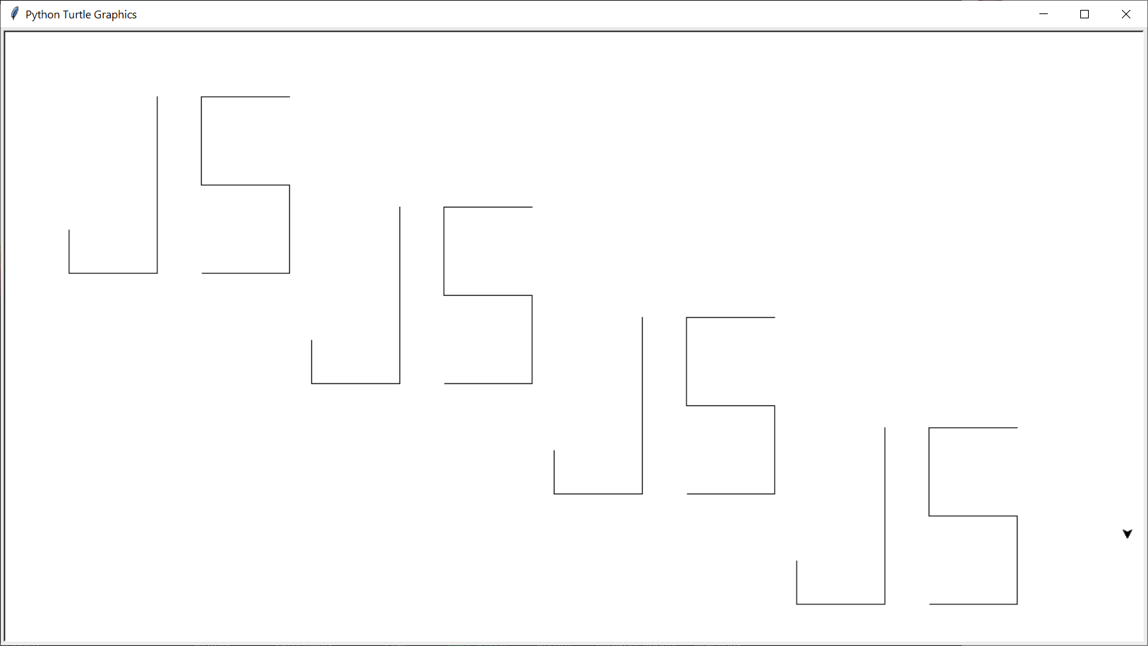

**110 Point Version Specifics and Output**

After your initials, you need to display each of the shapes/designs below, one at a time.

Remember, uncomment the 4 commands after each shape/design that you finish.

|  |  |
| --- | --- |
| Solid Red Octagon | 15-Point Star |
| Plus Sign | Big Thick Snowflake with 2 Thin Babies |
| Circle | Horizontal Zig-Zag |

|  |  |
| --- | --- |
| Cool Pattern | Flower of 12 Squares |
| Flower of 10 Circles | Westbound Comet |
| Box Spiral | Triple Nested Golden Honeycomb |

The following needs to be understood when doing this assignment:

1. This project will take more than one class period. You must save your work so you can continue to work on it later. It may be necessary that you work on your project at home as well.

2. You do the shapes/designs of this assignment in any order. Just make sure you put each in its proper location in the program. Regardless of the order in which you created the different shapes and designs, it will still execute in the same order (Diagonal Initials, Solid Red Octagon, 15-Point Star, Plus Sign, etc.)

3. Your drawings should be similar to the drawings shown in the provided output, but they do not have to match exactly:

a. Your pictures may be bigger or smaller.

b. Your pictures may be in a different part of the screen.

c. Your “turtle” may have a different final resting position.

d. However, one thing that must match is the *orientation*. Your drawings must be rotated the same way as the drawings shown in the provided output.

e. When doing the initials, they need to be YOUR initials; there need to be at

least 4 sets of YOUR initials and they must be EVENLY spaced.

f. You may not do any other shape/design until you have done YOUR initials.

4. You will only receive credit for a shape/design that is completely drawn. There is no partial credit for partially drawn shapes or designs.

5. You must use a *Triple Nested Loop* to create the 18 hexagons in the final image.

Also, all 18 hexagons must be visible on the screen and be evenly spaced.